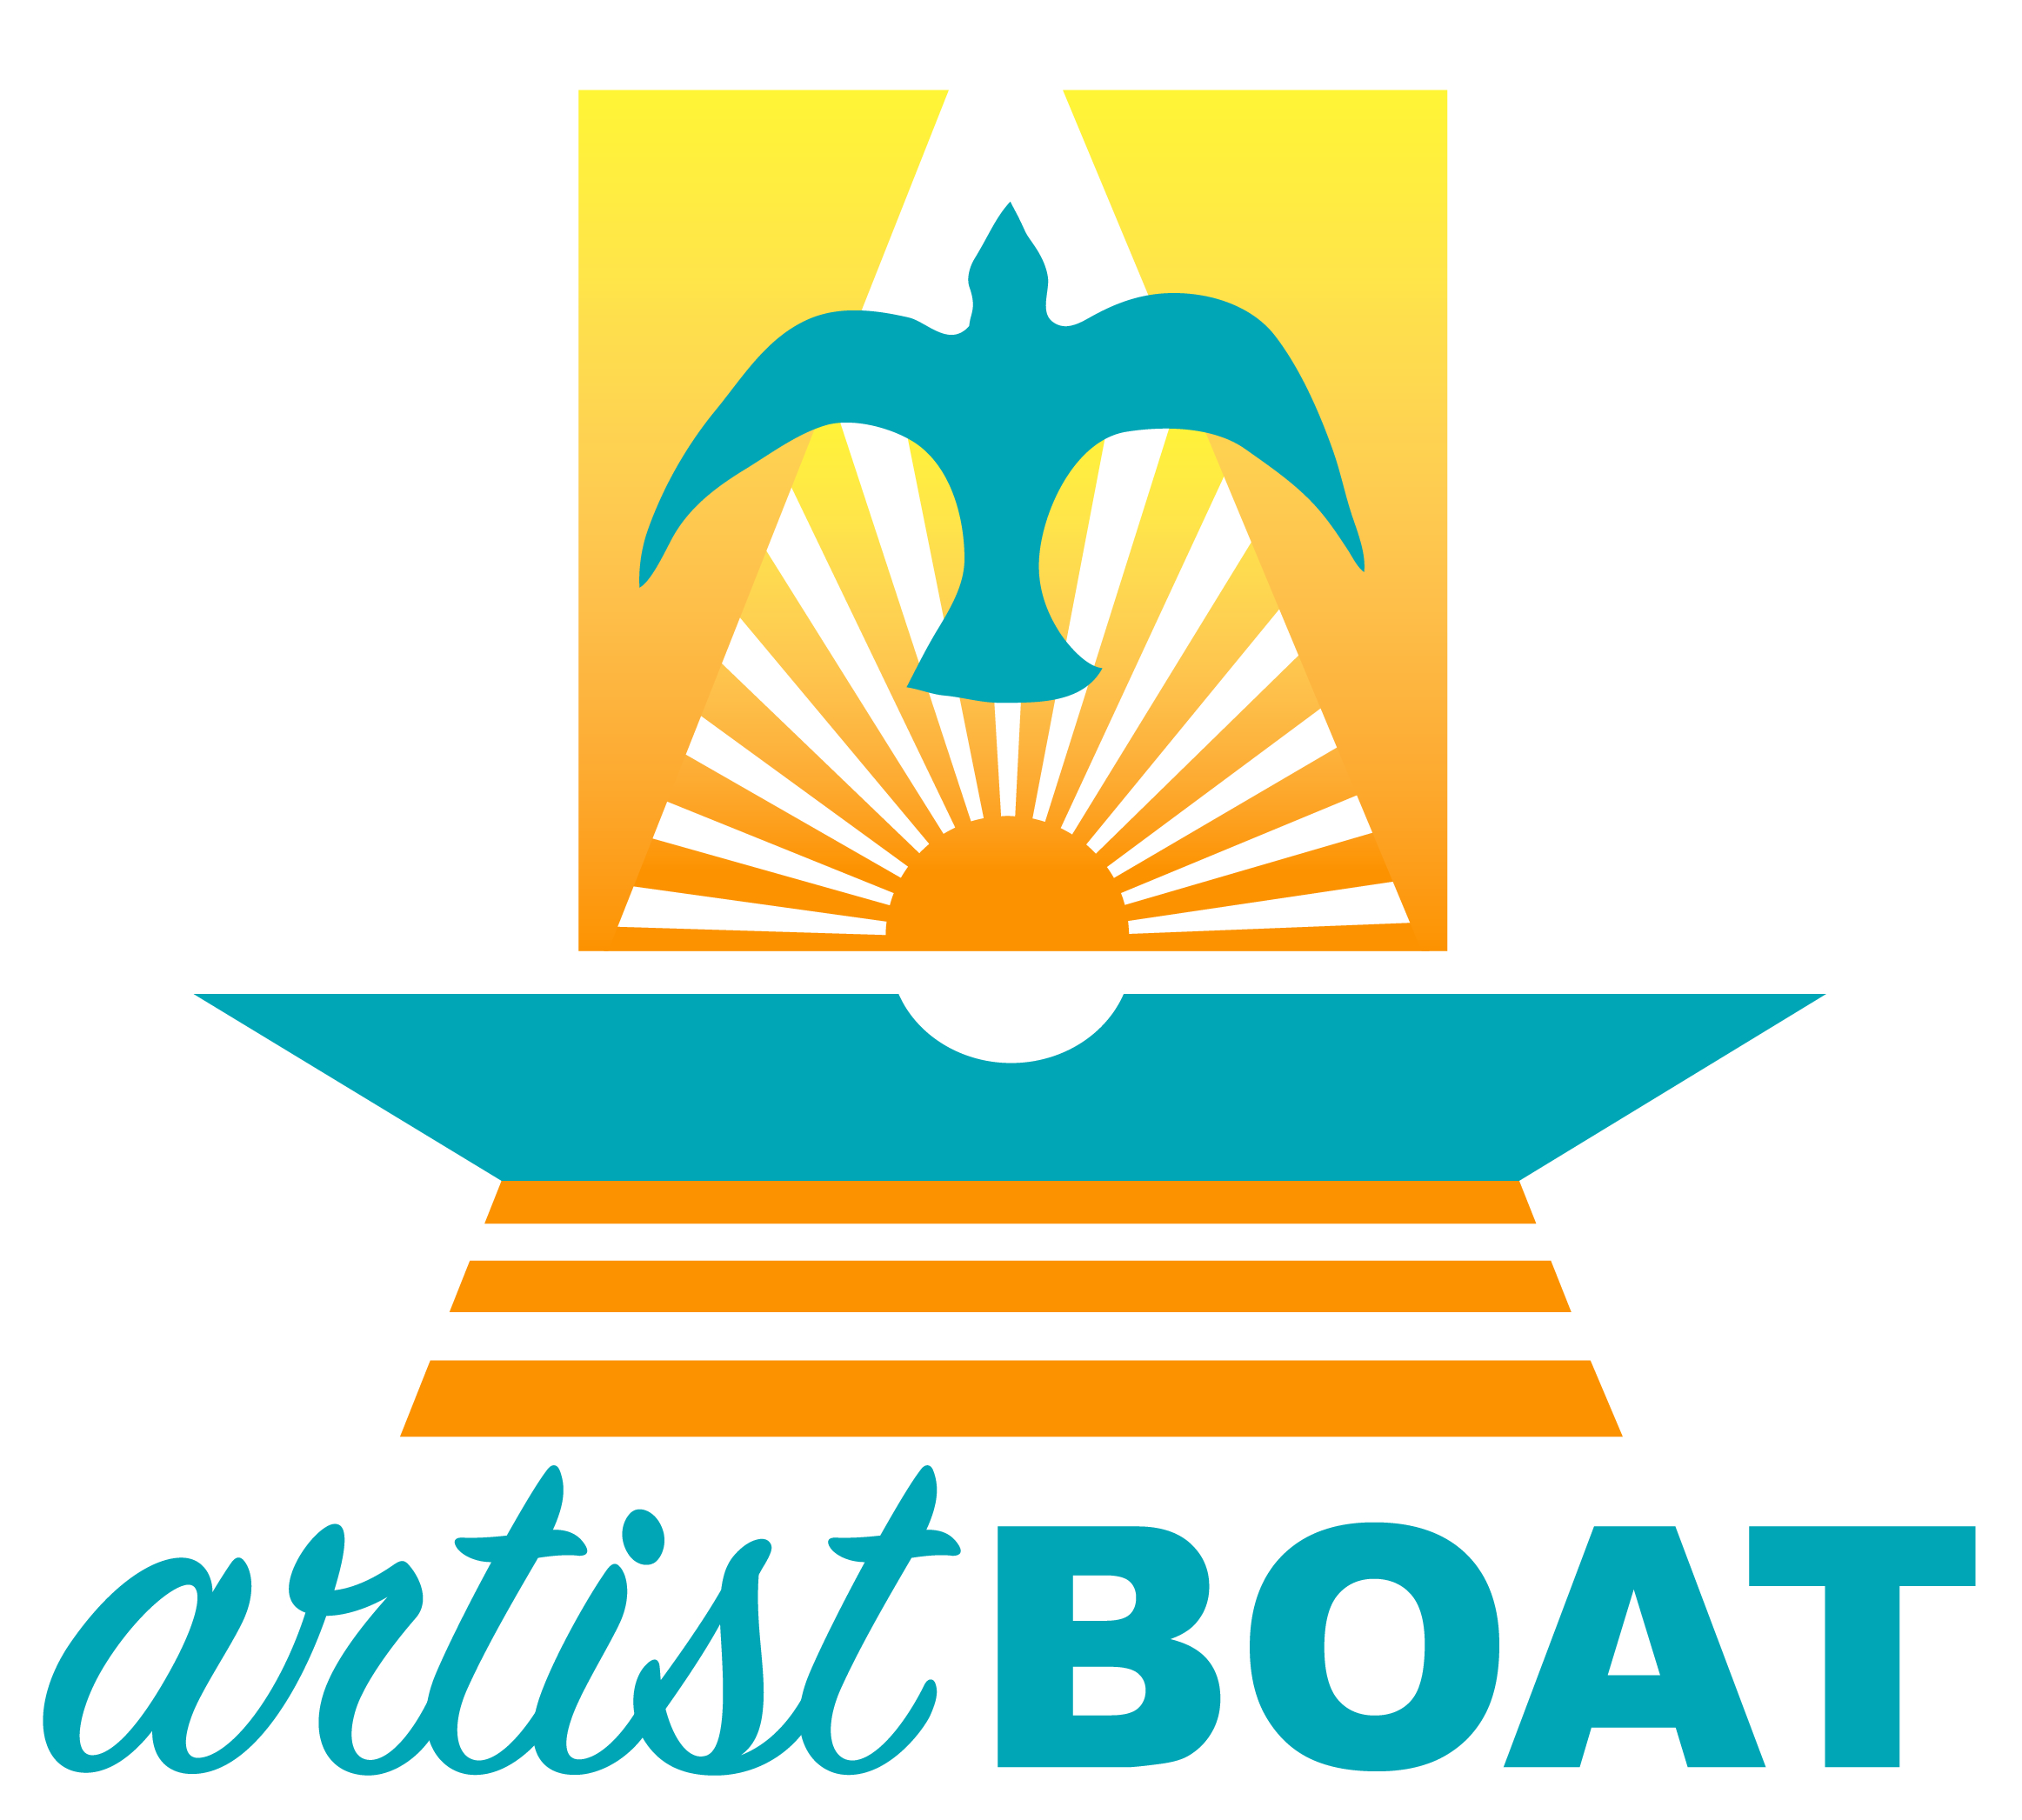
2020 Schedule of Special Events

Feb 10 to Mar 10: Beautify the Bucket Spring Registration

Mar 6 to 9: American Canoe Association Kayak Instructor Course

Mar 7 to Dec 13: Eco-art Kayak Adventures

Mar 9 to 13: Spring Break Eco-Art Camps

Apr 15: Beautified Buckets Due

Apr 15 to May 25: Marine Debris Art Contest Registration

Apr 18: Beautify the Bucket Art Competition Judging at Menard Park

Apr 25: The Great Texas Birding Classic at the Coastal Heritage Preserve

May 02 & 03: Blue Carbon Art Exhibit at the Bryan Museum

May 03: Blue Carbon Art Reception at the Bryan Museum

May 9: Bio-Blitz at the Coastal Heritage Preserve

May 23 to Sept 7: Bucket Brigade Tours at Stewart Beach

Jun 1: Marine Debris Art Contest Entries Due

Jun 5 to 8: World Ocean Exploration Days

Jun 5: World Ocean Day Seadrift Film Screening at Sea Star Base Galveston

Jun 6: World Oceans Day Beach Festival at Stewart Beach

Jun 7: Ocean Action Hero Award Luncheon at Ashton Villa

Jun 8 to Aug 7: Summer Break Eco-Art Camps

Jun 23 to 26: NOAA Planet Stewards Professional Development

Jul 20 to 23: Turn the T.I.D.E. Professional Development

Jul 1 to 31: Beautify the Bucket Fall Registration

Sept 3 to 6: American Canoe Association Kayak Instructor Course

Sept 9: Beautified Buckets Due

Sept 12: Beautify the Bucket Art Competition Viewing & Judging at Menard Park

Nov 14: Float the Boat Annual Fundraiser & Gala

Dec 23 & 28 to 31: Winter Break Eco-Art Camps

